Table of Contents
Paragraph Page

Purpose 1 1
Applicability 2 2
Explanation of Terms 3 2
References 4 2
Responsibilities 5 2
Procedures 6 4
Command and Control 7 7
Proponent 8 7

Appendix A - Sample Form DD 2795, Pre-Deployment Health Assessment A-1
B - Sample Weekly DNBI Report B-1
C - Sample Form DD 2796, Post-Deployment Health Assessment C-1

Glossary GL-1

1. Purpose. Public Law, Presidential declaration, and Department of Defense (DoD) policy require a functional medical surveillance system in place for all military forces deployed outside the United States. This publication establishes USSOCOM policy for conducting deployment medical surveillance to comply with the aforementioned requirements for Special Operations forces deployed outside the United States. These procedures encompass medical activities designed to provide medical surveillance during the full cycle of pre-deployment, deployment, employment, and post-deployment activities, as well as "cradle to grave" record keeping. The guidance is based upon guidelines established by the Office of the Assistant Secretary of Defense - Health Affairs (OASD-HA) and the Office of the Chairman, Joint Chiefs of Staff, J-4/Medical Readiness Division.

2. Applicability. This directive establishes roles, assigns responsibilities, and prescribes procedures for the establishment of medical surveillance programs for Headquarters, United States Special Operations Command (USSOCOM), component commands, sub-unified commands, and the theater Special Operations Commands (SOC).

3. Explanation of Terms (See Glossary Section II).

4. References (See Glossary Section III).

5. Responsibilities.

a. Commander in Chief, United States Special Operations Command, (CINCSOC) shall:

(1) Direct subordinate activity to implement a medical surveillance program in compliance with applicable policies and guidance supplied by the Joint Staff.

(2) Provide guidance for subordinate commands on the applicability of specific elements of their deployment medical surveillance programs.

(3) Monitor subordinate activity compliance with all reporting requirements in accordance with (IAW) USSOCOM reporting structure, USSOCOM Manual 525-1, USSOCOM Reporting Structure (SOCOMREP), 28 May 1991.

(4) Ensure medical surveillance programs extend to all deployed DoD personnel assigned or attached to USSOCOM to include active duty military and reserve/guard units.

(5) Support innovative medical surveillance technology development within the framework of DoD medical surveillance policy and architecture.

b. USSOCOM Command Surgeon (SOCS-SG) shall:

(1) Be the conduit for the collection of all SOF deployment medical surveillance data prior to transmission to Defense Medical Surveillance System (DMSS).

(2) Ensure medical surveillance data are collected and analyzed IAW DoD policy and Joint Staff guidance.

(3) Provide oversight and preliminary analysis of deployment medical surveillance data, including disease and non-battle injury (DNBI) data.

(4) Integrate deployment medical surveillance and readiness into the training of special operations medical personnel.

(5) Ensure that medical surveillance information is properly sanitized for operational security prior to transmission to the DoD central repository.

(6) Ensure transmission of deployment medical surveillance information is properly encrypted per the Privacy Act prior to data transmission to the DoD repository.

(7) Ensure that data are standardized and that all data captured and reported are appropriately forwarded to the DoD repository for centralization IAW references 3 through 5, in the glossary, section III. Ensure that all pre- and post-deployment data are forwarded to the DoD central repository.

(8) Identify and report illnesses and injuries of military significance during deployments to the CINCSOC and subordinate commands.

(9) Ensure continual re-evaluation of effectiveness, anticipation of problems, and flexibility to accommodate new technologies to improve data collection process for medical surveillance programmatics; advise CINCSOC on requirements for SOF deployment medical surveillance.

c. Subordinate Command Surgeons shall:

(1) Support medical surveillance requirements in compliance with applicable policies and guidance.

(2) Ensure that force health protection begins at the inception of planning and initial deployment.

(3) Identify/monitor/evaluate environmental, health, occupational and epidemiological threats.

(4) Assess disease and non-battle injuries, stress-induced, and combat casualties including those produced by weapons of mass destruction.

(5) Reinforce command directed and individual preventive countermeasures and the provision of optimal medical care before, during, and after deployment.

(6) Establish a communications network to keep force-providing commanders informed before, during and after deployment of health risks, and available countermeasures.

(7) Institutionalize pre- and post-deployment screening programs.

(8) Ensure patient encounters for battle injury and/or DNBI during deployment are reported and forwarded weekly through command channels to the USSOCOM Surgeon.

(9) Ensure transmission of deployment medical surveillance information is properly encrypted per the Privacy Act prior to data transmission to the USSOCOM Command Surgeon Medial surveillance cell.

(10) Ensure all surveillance data are collected and reported in Chairman, Joint Chiefs of Staff, (CJCS) approved format.

(11) Ensure that all medical surveillance data is compiled and placed within the appropriate military member's medical record with the use of standard medical encounter forms (e.g., standard form (SF) 600).

(12) Provide a monthly report listing all locations within geographical locations where medical care is provided by their respective subordinate command. This report will be submitted through command channels to USSOCOM Command Surgeon and is due NLT 1200 EST on the first duty day of each month. This report will be cross referenced with the list of reporting sites for the purpose of verifying that reports are being submitted by all sites where medical care is provided.

(13) Ensure a copy of ancillary medical and environmental surveillance reports required by geographic CINC are forwarded to USSOCOM Command Surgeon.

(14) Ensure all personnel meet Service requirements for deployment, i.e., current immunizations, deoxyribo nucleic acid (DNA) and human immunodeficiency virus (HIV) testing, as well as medical and dental screening.

d. Joint Special Operations Task Force (JSOTF) Commander shall:

(1) Establish procedures to comply with the weekly requirement for sending comprehensive DNBI and casualty data through command channels to USSOCOM with copies furnished to subordinate command surgeon(s).

(2) Ensure compliance with all subordinate command Surgeon requirements described in section 5(c).

(3) If a JSOTF Surgeon is not present, the deployed unit medical authority assumes these responsibilities.

6. Procedures. To prevent duplication of reporting, the following procedures will be implemented. See the following website for blank forms and specific JCS guidance: http://cba.ha.osd.mil/projects/other/depl-surv/depl-surv-main.htm.

a. Pre-deployment. Subordinate commands will ensure the following measures are conducted for all USSOCOM personnel, active and reserve components, prior to all outside the continental United States (OCONUS) deployments.

(1) A medical threat brief, to include command approved health hazard countermeasures, IAW reference 5 in glossary, section III, enclosure A, para 2.a.

(2) Completion of DD Form 2795, Pre-Deployment Health Assessment, (Appendix A) by USSOCOM members prior to deployment for any duration of time outside the United States.

(a) DD Form 2795 will be reviewed by a health care provider at their home station or processing station. The reviewer will be a credentialled medical officer or medic certified for independent duty.

(b) The completed DD Form 2795 will be placed in the service member's permanent medical record. Service member may revalidate previous DD 2795 if less than 6 months old in lieu of completion of a new DD form 2795.

(c) A copy of the DD Form 2795 will be immediately forwarded to the HQ USSOCOM/SOCS-SG, 7701 Tampa Point Blvd, USSOCOM, MacDill AFB, Florida, 33621-5223, (FAX DSN: 299-2568) based on the reporting requirements described in paragraphs 6d and 6e of this directive.

(d) Classified Activities. The guidance within the SOF deployment medical surveillance implementation and training packet (published separately) will be used.

(3) Administration of all required vaccines and tuberculosis (TB) testing. Proper documentation, IAW an approved Investigational New Drug protocol, is required in the patient's individual health record for any use of non-Food and Drug Administration approved vaccines(s).

(4) Distribution of prophylactic drugs for known endemic or epidemic threats must be accomplished before any deployment and in sufficient time for the medication to be effective.

b. Deployment. The JSOTF Surgeon, equivalent medical officer, or Special Operations medical member will ensure that:

(1) A DNBI monitoring system is initiated to track threats during the deployment.

- All patient encounters are collected on the SF 600.

(a) Data will be collected throughout the duration of the deployment for each patient encounter for all USSOCOM personnel deployed for any duration.

(b) The SF 600 will be placed in the service member's permanent medical record or the deployed medical record for transfer to their permanent medical record upon redeployment to their home station.

- All patient encounters will be reported on a Weekly DNBI Report (Appendix B).

(a) Copies of the weekly DNBI will be forwarded to the HQ USSOCOM/SOCS-SG, 7701 Tampa Point Blvd, USSOCOM, MacDill AFB, Florida, 33621-5223, (FAX: DSN 299-2568) based on the reporting requirements described in paragraph 6d through 6f of this directive.

(b) Collateral Activities. The guidance within the SOF deployment medical surveillance implementation and training packet will be used.

(c) The reporting period of the weekly DNBI is from 0001 Sunday to 2400 Saturday with report due NLT 1200 Monday. For missions that do not lend to routine reporting (i.e., would compromise mission), collective documentation will be forwarded upon return of mission.

(d) Data placed in the individual health record will be sanitized by the deployed medical provider based on operational security requirements and guidance within the SOF deployment medical surveillance implementation and training packet.

(4) Potential environmental and industrial exposures will be documented and reported to the greatest extent possible given operational capability limitations.

- Environmental and occupational exposures will be extracted from Special Operations
Debriefing and Retrieval System (SODAR) sections and reported to the Command
Surgeon at the end of the mission.

(5) Operational security and mission permitting, coordinate specialty consultations with appropriate military service environmental and preventive health laboratory servicing the particular area of responsibility (AOR) to respond to significant disease outbreaks and medical threats.

c. Post-Deployment. The JTF/JSOTF Surgeon, or equivalent medical officer, will coordinate with USSOCOM and the subordinate commands to complete the following:

(1) DD Form 2796, Post-Deployment Health Assessment (Appendix C) will be completed in theater prior to redeployment or immediately upon return to the home station for all USSOCOM personnel deployed for any duration.

(a) For deployments within a deployment, a DD Form 2796 will be filled out for each country visited.

(b) DD Form 2796 will be reviewed by a health care provider. The provider will be a credentialled medical officer or medic certified for independent duty.

(c) The completed DD Form 2796 will be placed in the service member's permanent medical record or the deployed medical record for transfer to their permanent medical record upon redeployment to their home station.

(d) A copy of the DD Form 2796 will be immediately forwarded to the HQ USSOCOM/SOCS-SG, 7701 Tampa Point Blvd, USSOCOM, MacDill AFB, Florida, 33621-5223, (FAX: DSN 299-2568) based on the reporting requirements described in paragraphs 6d and 6e of this directive.

(e) Classified Activities. The guidance within the SOF deployment medical surveillance implementation and training packet will be used.

(2) Collection of post-deployment serum sample, if required, for forwarding to the DoD Serum Repository. Collection of post-deployment sera is unauthorized unless directed by OASD-HA, geographic Commander in Chief (CINC) or CINCSOC.

(a) If the unit surgeon determines that a post-deployment serum should be kept within the DoD central repository, authority can be obtained by request forwarded to the USSOCOM Command Surgeon for ASD-HA approval.

(b) Individual cases that may clinically require post-deployment serum samples are determined by the unit surgeon.

(3) Forwarding of pre- and post-deployment screening program summary reports and analysis of DNBI data to the USSOCOM Command Surgeon's office, subordinate command Surgeons, and placement in the individual member's medical records.

(4) Document suspected or confirmed environmental exposures in after action reports (AAR) and send those data to the USSOCOM Command Surgeon's office.

d. All routine reportable data (i.e., DD Form 2795, DD Form 2796 and the weekly DNBI report) will be sent to the USSOCOM Command Surgeon for appropriate data collection or transmittal.

e. If data are reported through the Geographic CINC, a courtesy copy will be sent to the subordinate command Surgeon and USSOCOM Command Surgeon. These data will be clearly flagged as a courtesy copy to ensure that data are not duplicated in the DoD repository.

f. Deployed units are responsible to ensure that the DD Form 2795 and the DD Form 2796, are sanitized based on operational security requirements and placed in the individual medical records based on the guidance within the SOF deployment medical surveillance implementation and training packet.

g. Classified Activities. The guidance within the SOF deployment medical surveillance implementation and training packet will be used.

7. Command and Control. As the principal medical advisor to USCINCSOC, the USSOCOM Command Surgeon will exercise coordinating authority by one of the following ways:

a. If a SOTF has been established, then coordinating authority will be exercised through the JTF or JSOTF Surgeon.

b. When a JTF or JSOTF does not exist and is not envisioned, then coordinating authority will be exercised from USSOCOM through service subordinate command channels.

8. Proponent. The proponent for this directive is the Command Support Center (SOCS) and the Command Surgeon (SOCS-SG). Users are invited to send comments and suggested improvements to: HQ USSOCOM, ATTN: SOCS-SG, 7701 Tampa Point Blvd., MacDill AFB, FL 33621-5323.

(SOCS-SG)

FOR THE COMMANDER IN CHIEF:

OFFICIAL: THOMAS W. STEFFENS
Rear Admiral, U.S. Navy
Chief of Staff

LEO M. SMITH, JR.
Chief, Command Information Services Division, SOCS-DP-S

DISTRIBUTION: A; C

APPENDIX A

SAMPLE FORM DD 2795, PRE-DEPLOYMENT HEALTH ASSESSMENT

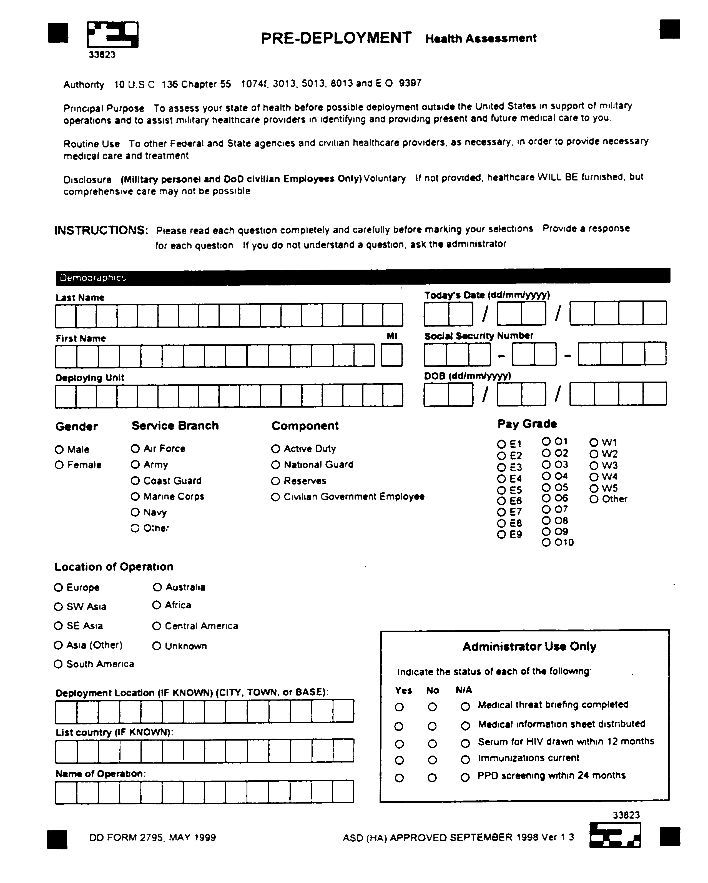

SAMPLE FORM DD 2795, PRE-DEPLOYMENT HEALTH ASSESSMENT
(CONT.)

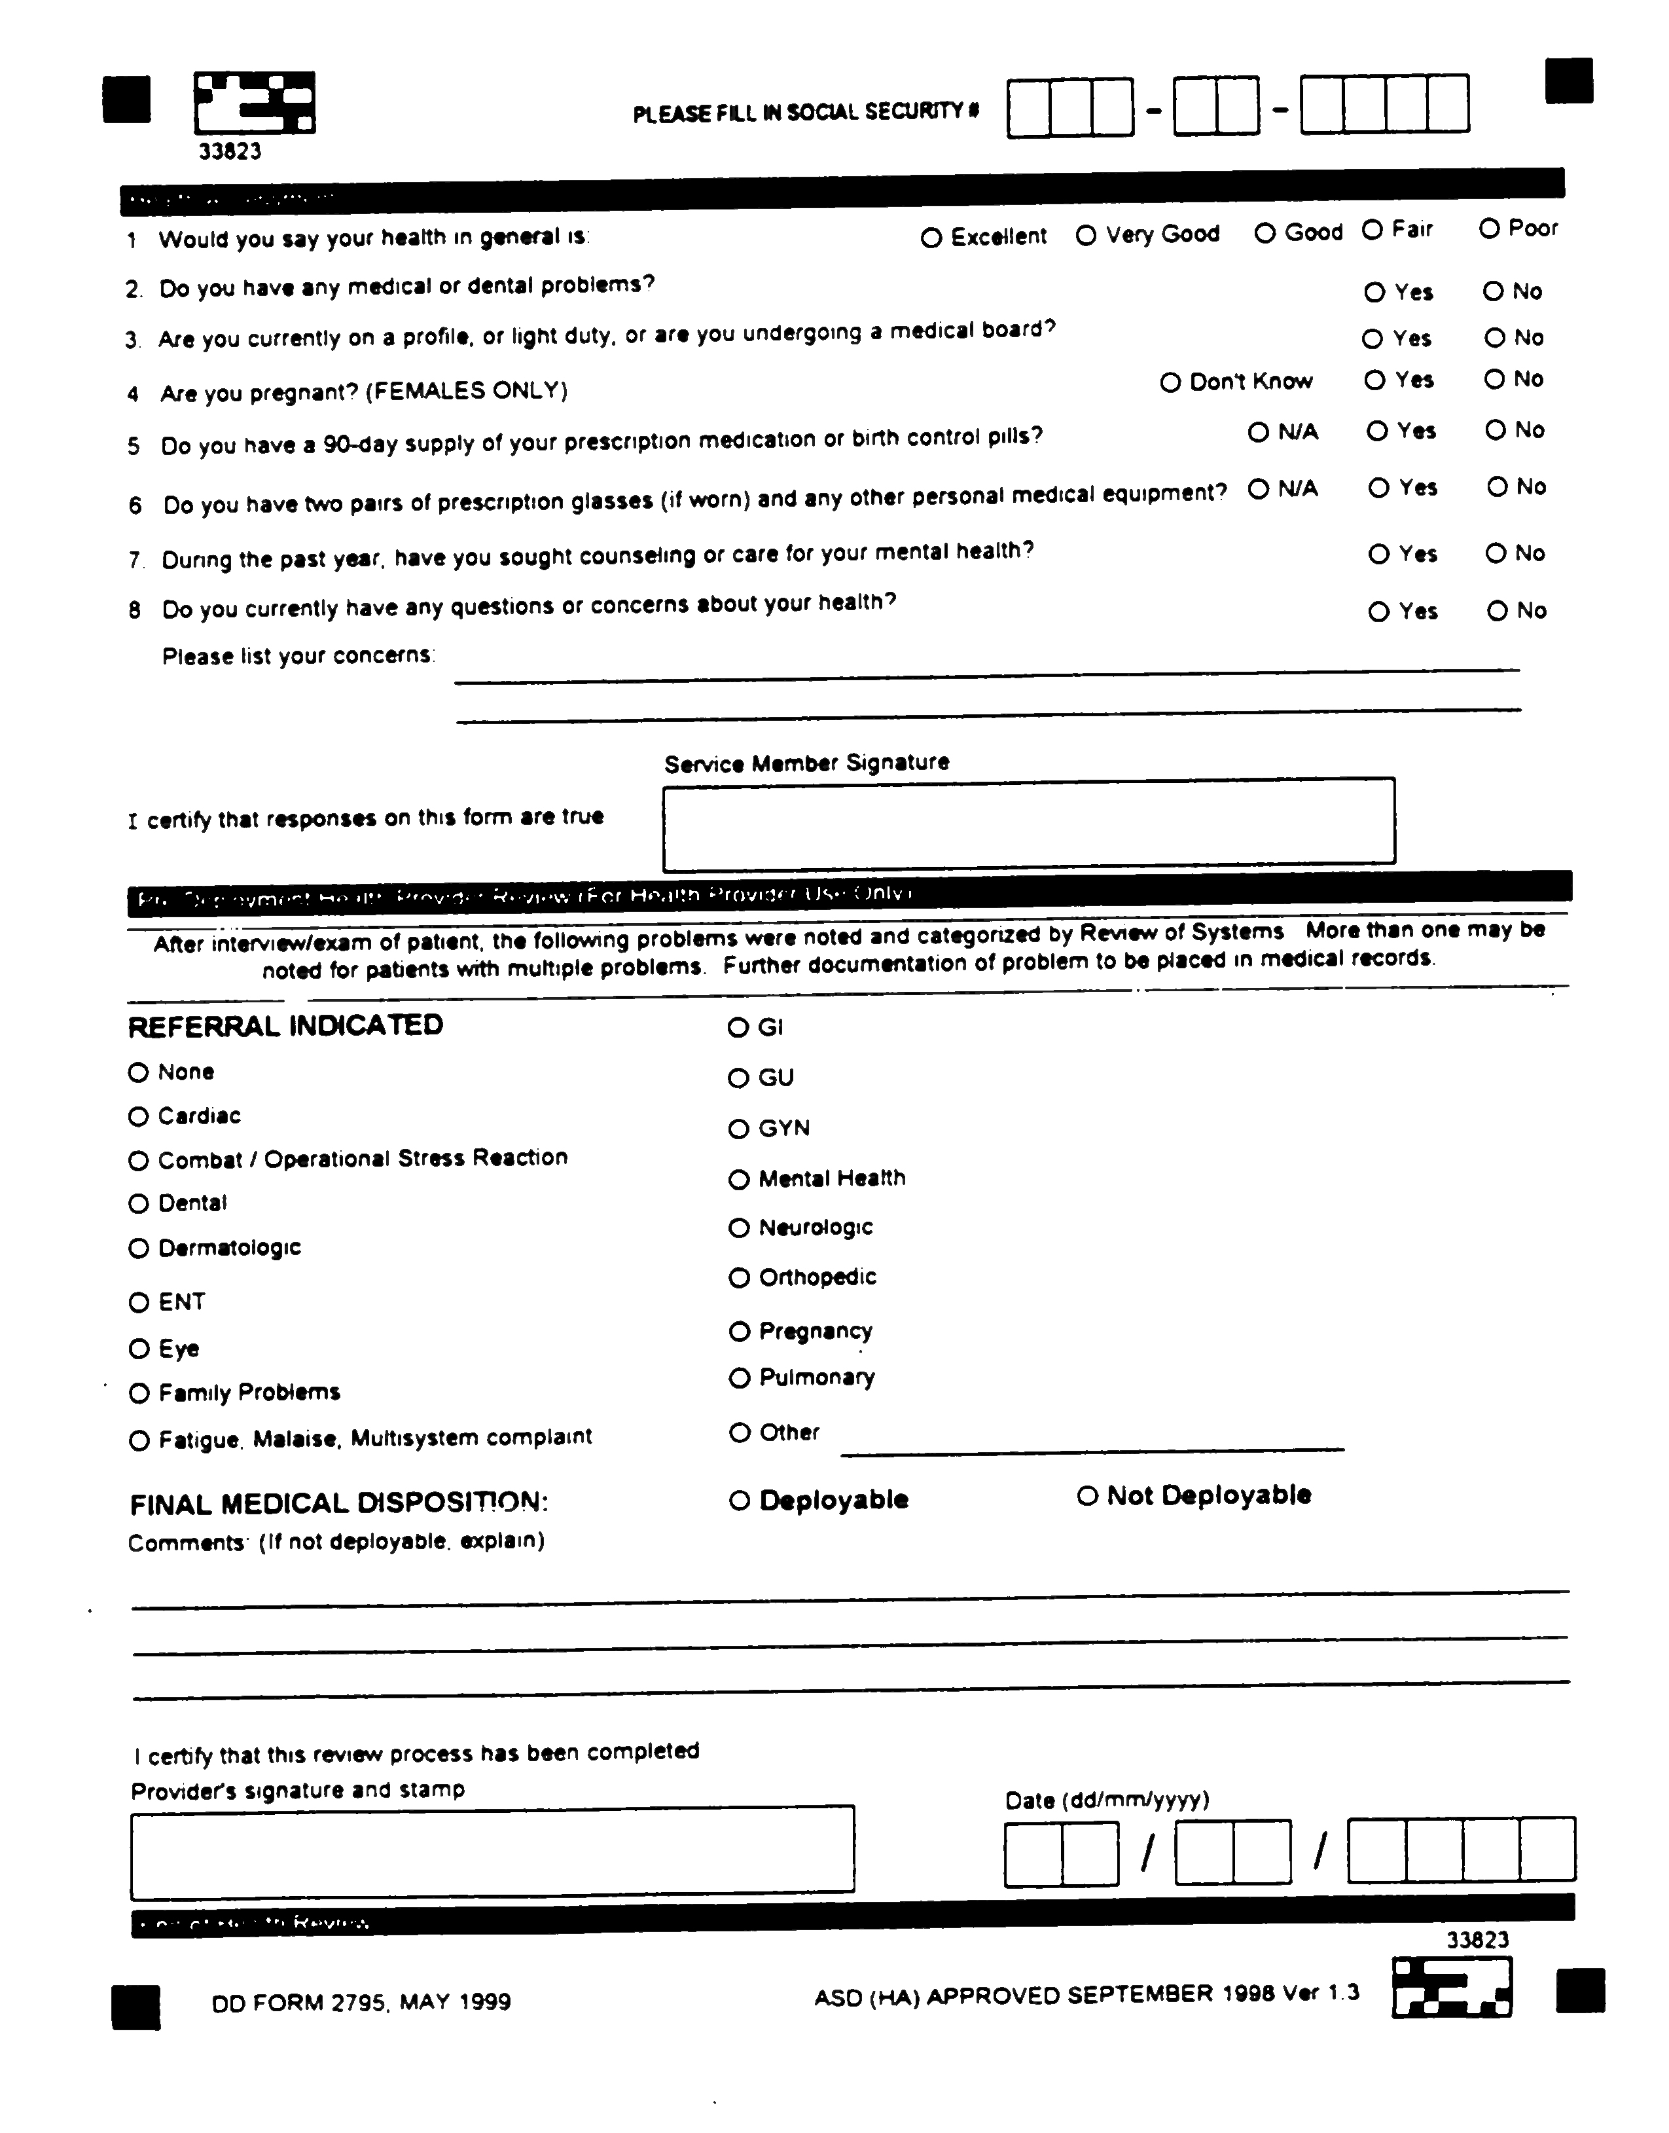

APPENDIX B

SAMPLE WEEKLY DNBI REPORT

Unit/Command: ____________________________ Troop Strength: _________________
Dates Covered: __________ (Sunday 0001) Through ___________ (Saturday 2359)

Individual Preparing Report: ___________________________________________________
Phone: _____________________ E-Mail: __________________________________________

CATEGORY | INITIAL  VISITS | RATE | SUGGESTED  REFERENCE  RATE |  | DAYS OF LIGHT  DUTY | LOST  WORK  DAYS | ADMITS
Combat/Operational  Stress Reactions |  |  | 0.1%
Dermatologic |  |  | 0.5%
GI, Infectious |  |  | 0.5%
Gynecologic |  |  | 0.5%
Heat/Cold Injuries |  |  | 0.5%
Injury,  Recreational/Sports |  |  | 1.0%
Injury, MVA |  |  | 1.0%
Injury, Work/Training |  |  | 1.0%
Injury, Other |  |  | 1.0%
Ophthalmologic |  |  | 0.1%
Psychiatric, Mental  Disorders |  |  | 0.1%
Respiratory |  |  | 0.4%
STDs |  |  | 0.5%
Fever, Unexplained |  |  | 0.0%
All Other,
Medical/Surgical
TOTAL DNBI |  |  | 4.0%

SAMPLE WEEKLY DNBI REPORT (CONT.)

CATEGORY | INITIAL  VISITS | RATE | SUGGESTED  REFERENCE  RATE |  | DAYS OF LIGHT  DUTY | LOST  WORK  DAYS | ADMITS
Dental |  | XXXXXXX
Misc/Admin/  Follow-up |  | XXXXXXX

Definable

Definable
Problems Identified: Corrective Actions:
______________________________________ _____________________________________
______________________________________ _____________________________________
______________________________________ _____________________________________

TRI-SERVICE REPORTABLE MEDICAL EVENT LIST

Amebiasis, Listeriosis
Anthrax Lyme Disease
Biological Warfare Agent Exposure Malaria (All)
Botulism Malaria, Falciparurn
Brucellosis Malaria, Malariae
Campylobacter Malaria. Ovale
Carbon Monoxide Poisoning Malaria, Unspecified
Chemical Agent Exposure Malaria. Vivax
Chlamydia Measles
Cholera Meningococcal Disease
Coccidioidomycosis Meningitis
Cold Weather Injury (All) Septicemia
Frostbite Mumps
Hypothermia Pertussis
Immersion Type Plague
Unspecifled Pneumococcal Pneumonia
Cryptosporidiosis Poliomyelitis
Cyclospora Q Fever
Dengue Fever Rabies. Human
Diphtheria Relapsing Fever
E. Coli 0157:H7 Rheumatic Fever, Acute
Ehrlichiosis Rift Valley Fever
Encephalitis Rocky Mountain Spotted Fever
Filariasis Rubella
Giardiasis Salmonellosis
Gonorrhea Schistosomiasis;
H. Influenzae, Invasive Shigellosis
Hantavirus Infection Smallpox
Heat Injuries Streptococcus, Group A, Invasive
Heat Exhaustion Syphilis (All)
Heat Stroke Syphilis, Congenital
Hemorrhagic Fever Syphilis. Latent
Hepatitis A Syphilis, Primary/Secondary
Hepatitis B Syphilis. Tertiary
Hepatitis C Tetanus
Influenza Toxic Shock Syndrome
Lead Poisoning Trichinosis
Legionellosis Trypanosomiasis
Leishmaniasis (All) Tuberculosis. Pulmonary
Leishmaniasis, Cutaneous Tularemia
Letshmaniasis, Mucocutaneous Typhoid Fever
Letshmaniasis, Unspecified Typhus Fever
Leishmaniasis. Visceral Urethritis, Non-Gonococcal
Leprosy Vaccine. Adverse Event
Leptospirosis Varicella, Active Duty Only
Yellow Fever

APPENDIX C

SAMPLE FORM DD 2796, POST-DEPLOYMENT HEALTH ASSESSMENT

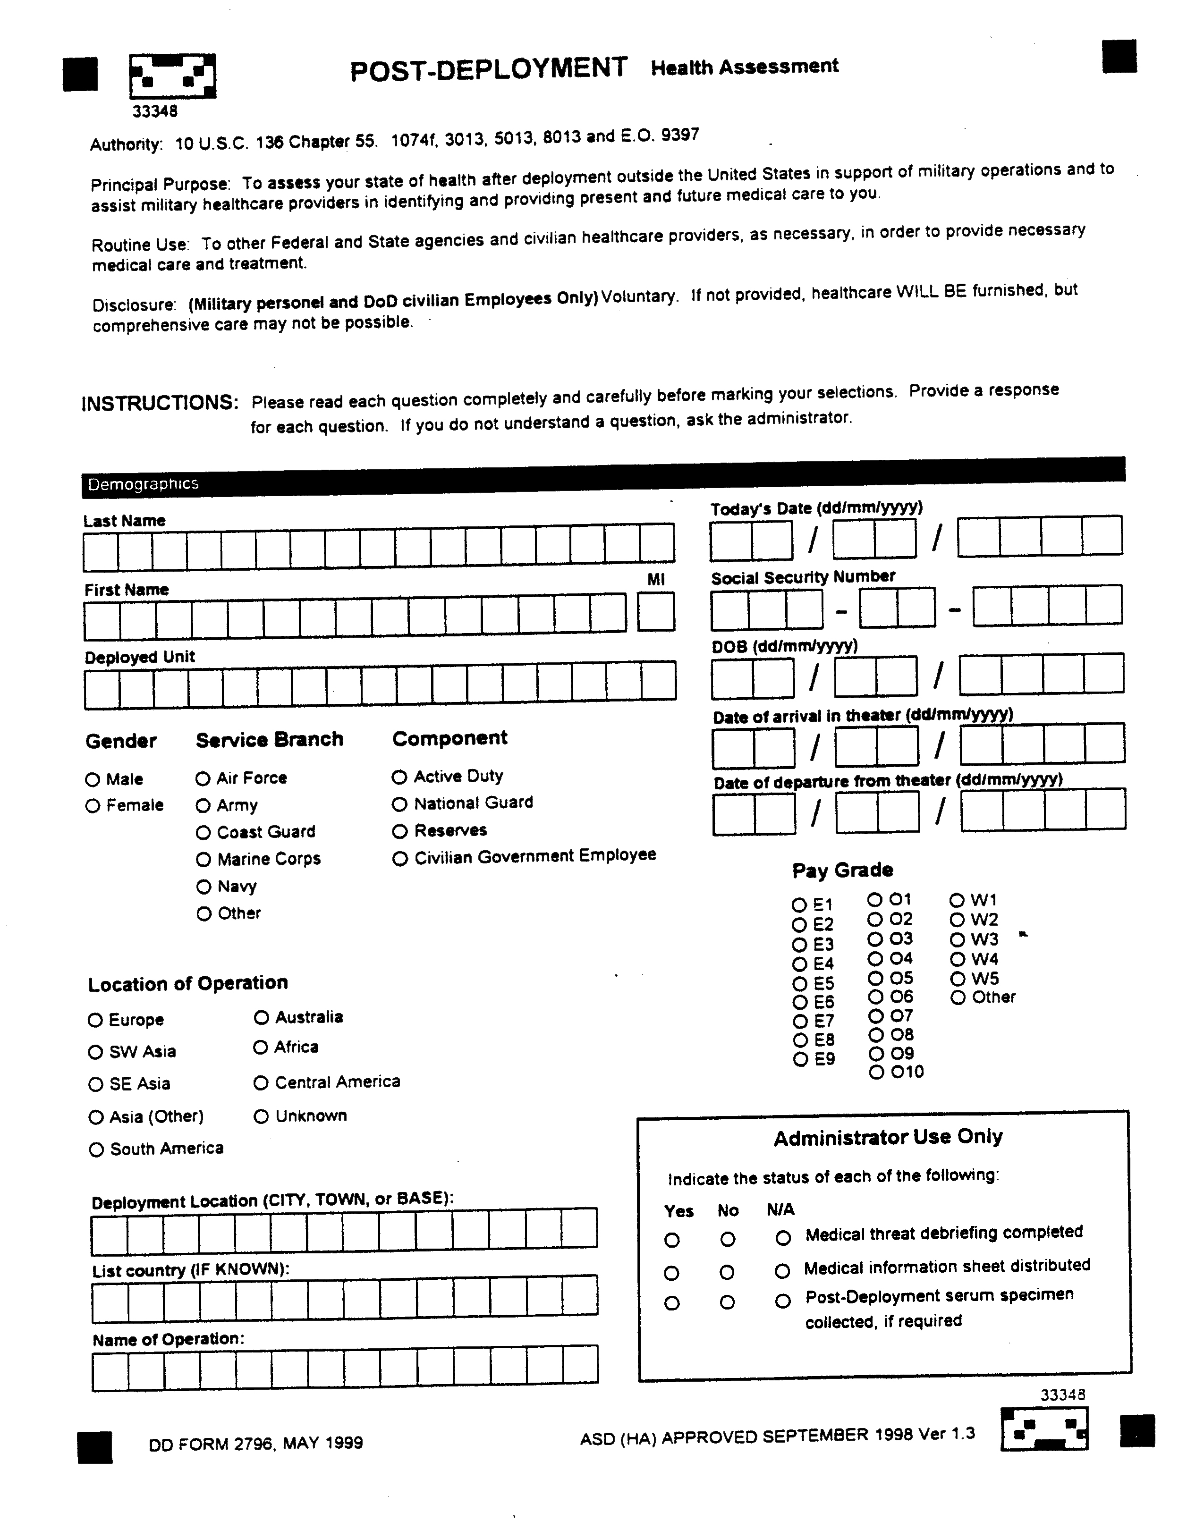

SAMPLE FORM DD 2796, POST-DEPLOYMENT HEALTH ASSESSMENT
(CONT.)

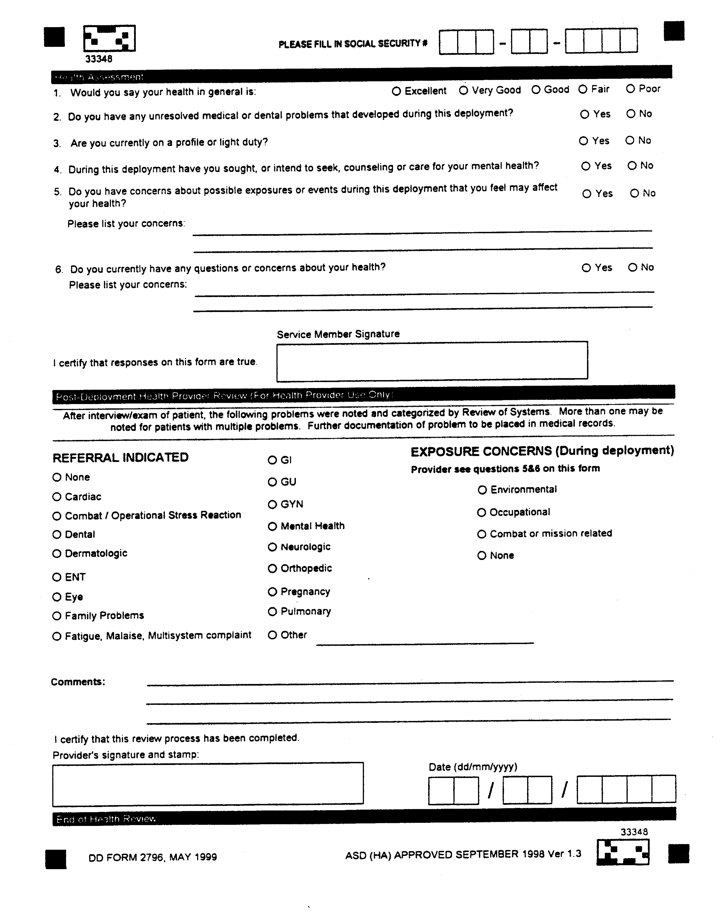

GLOSSARY

SECTION I--ABBREVIATIONS AND ACRONYMS

AAR after action reports
AOR area of responsibility
CJCS Chairman, Joint Chiefs of Staff
CHPPM Center for Health Promotion and Preventive Medicine
CINC Commander in Chief
CINCSOC Commander in Chief, United States Special Operations Command
DoD Department of Defense
DMSS Defense Medical Surveillance System
DNA deoxyribo nucleic acid
DNBI Disease And Non-Battle Injury
HIV human immunodeficiency virus
IAW in accordance with
JCS Joint Chiefs of Staff
JSOTF Joint Special Operations Task Force
JTF Joint Task Force
PAR Population At Risk
OASD-HA Office of the Assistant Secretary of Defense - Health Affairs
SOCS-SG USSOCOM Command Surgeon
SF Standard Form
SOC Special Operations Commands
SOCS Command Support Center
SOCS-SG Command Surgeon
SODAR Special Operations Debriefing and Retrieval System
SOF Special Operations Forces
USSOCOM United States Special Operations Command

SECTION II--DEFINITIONS

Deployment. For the purpose of this directive, deployments that require medical surveillance include all principal special operations missions and all special operations collateral activities that are outside the United States regardless of length of stay. This directive does not include routine naval and aircraft deployments, unless the mission involves landfall or potential significant exposures.

Medical Surveillance (This directive only). The regular or repeated collection, analysis, and dissemination of uniform health information for continuous monitoring of the health of a population and exposures, safety matters potentially impacting on force health, in order to intervene in a timely manner when necessary. It involves enhanced methods of systematically and continuously collecting information on personnel before, during and after a military operation, to include the full cycle of pre-deployment, deployment, employment, and post deployment activities, encompassing "cradle to grave" service member record keeping to reflect health events as well as potentially adverse health exposures.

Population At Risk (PAR). This is the Special Operations Forces (SOF) Warfighters, both well and ill. Targeted surveillance of PAR exposures, injuries, and illnesses during all phases of the deployment cycle, and systematic collection and documentation of that information satisfy the "cradle to grave" requirement to document significant health-related events and potentially adverse exposures encountered during deployment.

Subordinate Command. For the purposes of this Directive a subordinate activity or subordinate command refers to the subordinate commands, sub-unified commands, and the theater Special Operations Commands (SOC).

SECTION III--REFERENCES

10 U.S.C. § 1074f, Medical Tracking System for Members Deployed Overseas, 18 November 1997.

DoD Directive 6490.2, Joint Medical Surveillance, 30 August 1997.

DoD Instruction 6490.3, Implementation and Application of Joint Medical Surveillance for Deployments, 7 August 1997.

DoD ASD-Health Affairs Memorandum, Policy-Establishment of DoD Centers for Deployed Health, 30 September 1999.

Joint Staff Memorandum MCM-251-98, Deployment Health Surveillance and Readiness, 4 December 1998.

US Special Operations Command Manual 525-1, USSOCOM Reporting Structure (SOCOMREP), 28 May 1991.

Joint Pub 4.02, Health Service Support in Joint Operations, 26 April 1995.

Joint Publication 3-05, Doctrine for Joint Special Operations, 17 April 1998.

