1/5/2003  0830 | PPD#2  S/P NSVD, Female, 2° perineal lac., Breast-feeding.  Feels fine, no C/O  VS: Normal. Afeb.  Breasts soft, NT  Abd: Uterus firm, at U-1, NT  Calves: no tenderness  Lochia: non-foul  Perineum: Intact  Labs: CBC yesterday:  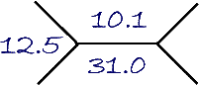  A/P: Stable PPD#2  Home today per Attending  Routine PP instructions given  Begin OCPs in 2 weeks  F/U visit in 6 weeks  Rx: PNVs One PO Daily  FeSo4 325 mg PO TID #150  Triphasil 28s One PO QD #3 Packs  Mike Hughey, MD  PG-1

