Vulvar Intraepithelial Neoplasia OB-GYN 101 Facts Card ©2003 Brookside Press

VIN is a premalignant condition, which if untreated can lead to invasive cancer of the vulva.
In the cervix, premalignant changes occur (CIN I, CIN II and CIN III) which precede the development of invasive cancer by many months or years.
In the case of the vulva, the same principle applies, that there are premalignant changes which may ultimately lead to cancer of the vulva. The degree of change is similarly labeled, VIN I, VIN II and VIN III (also known as "carcinoma-in-situ).
Clinically, these patient usually present with vulvar itching which does not respond to anti-fungal agents. Closer inspection visually will show the skin to have a white discoloration which can be enhanced with the application of acetic acid.
Milder forms of VIN may not be obvious visually and special testing, such as the use of Toluidine Blue staining, may be necessary to identify the area of abnormality.
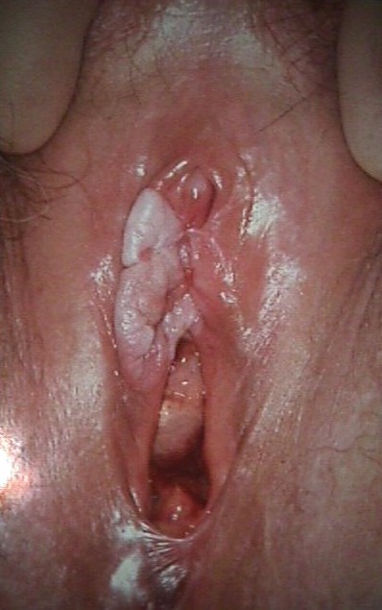
The diagnosis is confirmed with vulvar biopsy.
Treatment involves local excision, or in selected cases laser vaporization. Close follow-up is very important should there be persistence or recurrence of disease.

