Prolonged Latent Phase OB-GYN 101 Facts Card ©2003 Brookside Press

Labor is regular, frequent uterine contractions leading to progressive change in the cervix. Usually, labors begin gradually, with very slow change up to 4 cm. This part of labor is called the latent phase. Latent phase labor can last hours or days.
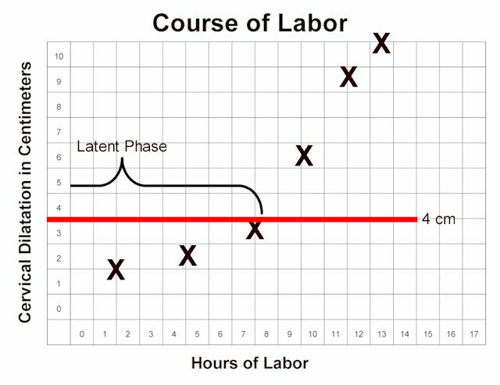
Prolonged latent phase:
- >20 Hrs. 1st baby
- >12 Hrs. 2nd baby
Risks:
- Exhaustion
- Chorioamnionitis
Treatments:
- Rest
- Ambulation
- Hydration
- Analgesia (narcotics such as Demerol 50-100 mg IM, Morphine 7.5-15 mg IM, Dilaudid 1-2 mg IM, etc.)
- Oxytocin stimulation

