Nuchal Cord OB-GYN 101 Facts Card ©2003 Brookside Press

This is a frequent occurrence during delivery. Nearly half of babies have the umbilical cord wrapped around something (neck, shoulder, arm, etc.), and this generally poses no particular problem for them.
During labor, the only indication of the umbilical cord being wrapped around the baby may be variable fetal heart decelerations on the fetal monitor. These are generally timed with contractions as that is the time the cord is stretched more tightly.
In a few cases, the cord will be wrapped so tightly around the baby's neck (after delivery of the head but before the shoulders are delivered) that you cannot get the rest of the baby out without risk of tearing the umbilical cord.
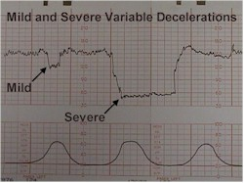
- If you can easily slip the cord over the baby's head, go ahead and do that.
- If the cord is relatively loose, and allows the baby to be born with the cord around its' neck, go ahead and do that.
- If the cord is tight and disallows any manipulation, double clamp the cord and cut between the clamps. This will free the cord. With this approach, prompt delivery of the rest of the baby is important as you have just cut off all blood flow in and out of the baby.

