Arrest of Labor OB-GYN 101 Facts Card ©2003 Brookside Press

During active labor (> 4 cm), the cervix should dilate at a rate of:
- 1.2 cm/hour (for first babies)
- 1.5 cm/hour (for subsequent babies).
Slower than this is arrest of labor:
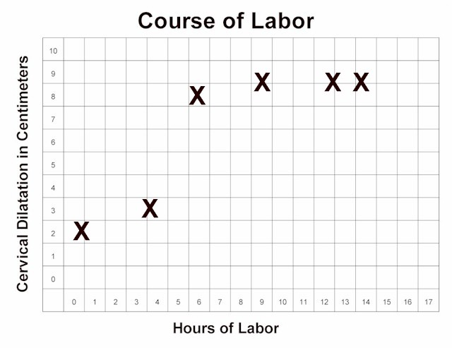
- Slower than expected
- Complete arrest (no Δ in 2 hrs.)
2 causes:
- Inadequate contractions, or
- Mechanical impediment.
Mechanical impediments include:
- Absolute fetal disproportion,
- Relative fetal disproportion,
- Fetal malposition
- Asynclitism
Inadequate contractions are treated with uterine stimulation:
- Oxytocin by infusion pump
- Nipple stimulation
Target: Contractions Q 2-3 minutes x 60 seconds. If contractions >Q2 minutes, slow down the oxytocin.

If no Δ in 2 hrs, despite adequate contractions, consider C/S.

