General Medical Officer (GMO) Manual: Administrative Section
Navy Personnel Command (NPC) References
Department of the Navy
Bureau of Medicine and Surgery
Peer Review Status: Internally Peer Reviewed

- Introduction

Maintenance of your Officer Data Card (ODC)/Performance Summary Report (PSR) and microfiche are very important in ensuring your success when it is time for your record to be presented at the promotion board. The following references will assist you in improving your advancement potential:

- Mailing of Fitness Reports (Fitreps) and Evaluations

- Standard mail

- COMMANDER, NAVY PERSONNEL COMMAND
PERS 311
5720 INTEGRITY DRIVE
MILLINGTON, TN 38055-3110
Phone: DSN 882-3316 / COMM (901) 874-3316

- Certified mail or FED/EX

- COMMANDER, NAVY PERSONNEL COMMAND
PERS 311
BLDG 769 – WOOD HALL
5751 HONOR DRIVE
Millington, TN 38055-3110

- Photographs

- COMMANDER, NAVY PERSONNEL COMMAND
PERS 313C
5720 INTEGRITY DRIVE
MILLINGTON, TN 38055-3130

- Mailing of ODC Corrections

- COMMANDER, NAVY PERSONNEL COMMAND
PERS 312G
5720 INTEGRITY DRIVE
MILLINTON, TN 38055-3120
Fax: DSN 882-2660

- Microfiche and OSR Corrections

- COMMANDER, NAVY PERSONNEL COMMAND
PERS 313C
5720 INTEGRITY DRIVE
MILLINGTON, TN 38055-3130
Phone: DSN 882-3407/08/10/18, COMM (901) 874-3407/08/10/18
Fax: DSN 882-2664 / COMM (901) 874-2664

- Submission of Missing Awards

- NAVY DEPARTMENT BOARD OF DECORATIONS AND MEDALS
ATTN: N09B33
NAVY PENTAGON 2000
WASHINGTON, D.C. 20350-2000
Phone: (202) 685-1764

- The Perspective (NAVPERS 15892)
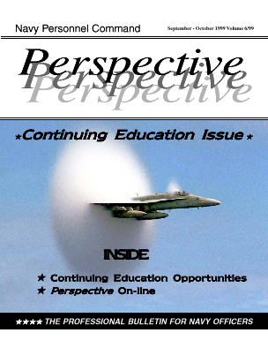
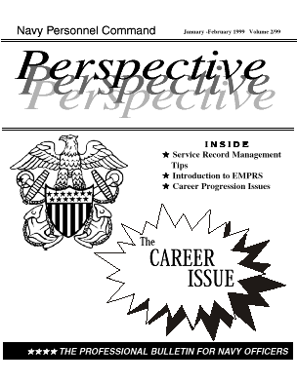
This is the professional bulletin of the navy officer community. Its mission is to provide all navy officers information regarding key personnel policy changes, reassignment trends, and emerging developments within their areas of expertise to enhance their professional development. Perspective is published bimonthly by the Assistant Commander, Navy Personnel Command for Distribution, Navy Personnel Command, Millington, Tennessee. The Perspective Career Issue is first issue of each year and is highly recommended as a career management resource. This publication can also be accessed on-line at http://www.bupers.navy.mil/periodicals/perspective/ .

Resources

- Navy Personnel Command homepage http://www.bupers.navy.mil/

- PERSPECTIVE, The Career Issue, January-February 1999, Volume 2/99.

Written by LT Denis Ashley MC, USNR, 00MC, Bureau of Medicine and Surgery, Washington, D.C. with review by LCDR Margo Haley Brown, MSC, USN, Special Assistant for Staff Boards, Navy Personnel Command (PERS-85M), Millington, Tennessee. DSN: 882-4524 COMM: 901-874-4524 FAX: 882-2751 COMM: 901-874-2751 E-MAIL: p85m@bupers.navy.mil HOMEPAGE: http://www.bupers.navy.mil/ (1999).

