General Medical Officer (GMO) Manual: Administrative Section

Awards and Medals
Department of the Navy
Bureau of Medicine and Surgery
Peer Review Status: Internally Peer Reviewed

- Basics on Recognition Awards

As a naval officer you are a respected leader and role model. As such, it is extremely important for you to recognize the people who work for you, civilian and military alike.

- 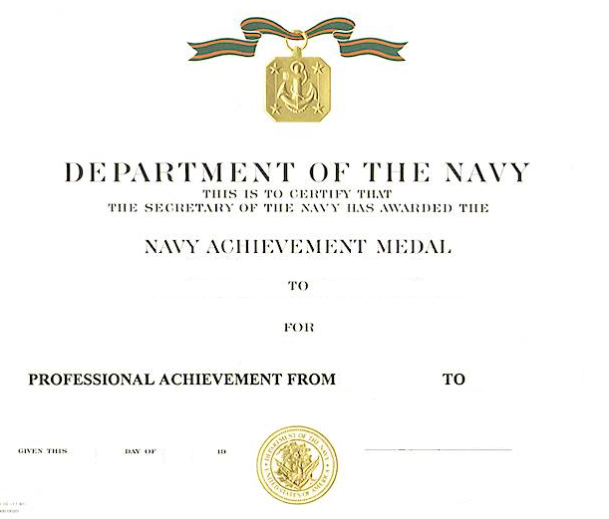For military personnel, an award can range from a simple, positive comment about a junior's performance to writing the person up for a medal. More commonly, enlisted people are nominated for Sailor of the Quarter honors. Criteria are locally developed and you should consult the local instruction for nomination procedures. Enlisted awards such as flag officer letters of commendation and medals add to the Sailor's final multiple for advancement.

- Most commands have a local awards system that covers granting awards such as Letters of Recognition, Letters of Appreciation, and Letters of Commendation. These are generally easy to accomplish for deserving personnel and can be used for either military or civilian personnel.

- Letters of recognition, appreciation, and commendation should come from the command. This means that you write it in memorandum form and submit it up the chain of command to the commanding officer. Most commanding officers appreciate the opportunity to reward deserving individuals; your write-up will most likely be approved with some minor modifications.

- Your people will work harder if they perceive you genuinely appreciate them. One of the basic tenets of leadership is that a good leader takes care of his or her people.

- For assistance in getting started, see your civilian personnel officer if the recipient is a civilian, or your personnel officer if the recipient is military. Your senior medical department representative can generally supply a draft award to use as a "go-by."

- Medals and Decorations

Generally, medals and decorations are classified into three types: personal, unit, and service. Personal awards are for individual heroic or meritorious acts. Unit awards are awarded to ships, squadrons, commands, or units for heroic or meritorious acts. Service awards recognize individuals for duty in areas of particular concern, like the Vietnam Service Medal or the Navy and Marine Corps Overseas Service Ribbon.

As an individual, you have a greater influence over being awarded a personal award or decoration than the other two types, so this section will not address unit and service awards. You should be notified in the Plan of the Day if you receive one or are eligible to receive one.

- Types of Medals

Personal decorations range from the Medal of Honor at the high end to the Combat Action Ribbon at the low end. The three most commonly awarded decorations for noncombat action are the Meritorious Service Medal, Navy Commendation Medal, and the Navy and Marine Corps Achievement Medal (from highest to lowest precedence). Because you are most likely to be recommended for, or to recommend someone else for one of these medals, the following discussion will be limited to these three.

Meritorious Service Medal | Navy and Marine Corps Commendation Medal | Navy and Marine Corps Achievement Medal
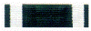
This award is the counterpart to the Bronze Star Medal for recognition of noncombat service. Individuals recommended for this medal must have distinguished themselves through exceptionally meritorious conduct in performing outstanding service. As a junior officer, you are unlikely to be recommended for this award, but you may be called upon to draft a recommendation for your department head or director. | This award is given for meritorious service or achievement, which is well above the performance usually expected of a person of that grade or rate. You might receive this medal if circumstances put you in a position where you were called on to do more than would normally be expected. For instance, handling mass casualties during a disaster at sea as the only medical officer. You would recommend your chief or first class for this award if they did an outstanding job standing in as department head for you aboard ship during a prolonged absence. | This award is given to enlisted and officer members of the Navy and Marine Corps of the grade of lieutenant commander or major and below. To get this award, you must do more than just your regular job. You might receive this award if you developed a mass casualty plan at a command where none existed before and coordinated a successful mass casualty drill.

- How to Get Recommended for Medals

- Look for opportunities to excel outside the limits of your job. You will stand out from other personnel if
you tackle additional duties not required by your job, for example volunteering as the chairperson of the
Navy Relief Fund Drive or the Combined Federal Campaign.

- Be reliable. If you say you are going to do something, do it. Being reliable gets you noticed and getting
noticed leads to good fitness reports and maybe a recommendation for a medal.

- How do you Prepare a Recommendation for a Medal

- You must refer to the Awards Manual (SECNAVINST 1650.1) for guidance and hints on the proper format
for an awards recommendation. Ask your personnel officer for this reference.

- Use the form OPNAV 1650/3, Personal Award Recommendation. The form is template for this task. This
can be obtained from your personnel officer.

- Submit the form through the chain of command or return it to the person who tasked you to do it.

- Hints Not Found In the Manual
- Stay within the length requirements for the citation and the summary of action.
- Use hard hitting action verbs and, wherever possible, quantify accomplishment, (i.e., number of dollars saved, number of people saved, number of hours saved). Numbers paint a better picture than overdone prose.
- Ask for assistance from the chief, the personnel officer, or the administrator. They generally have more experience and can provide valuable advice on how to prepare an award.
Reference

- The Navy and Marine Corps Awards Manual, SECNAVINST 1650.1

Reviewed and revised Ms. Sandy Barker, MED-05X, Awards Coordinator, Education, Training, and Personnel, Bureau of Medicine and Surgery, and by LT Denis Ashley, MC, USNR, 00MC, Bureau of Medicine and Surgery, Washington, D.C. (1999).

